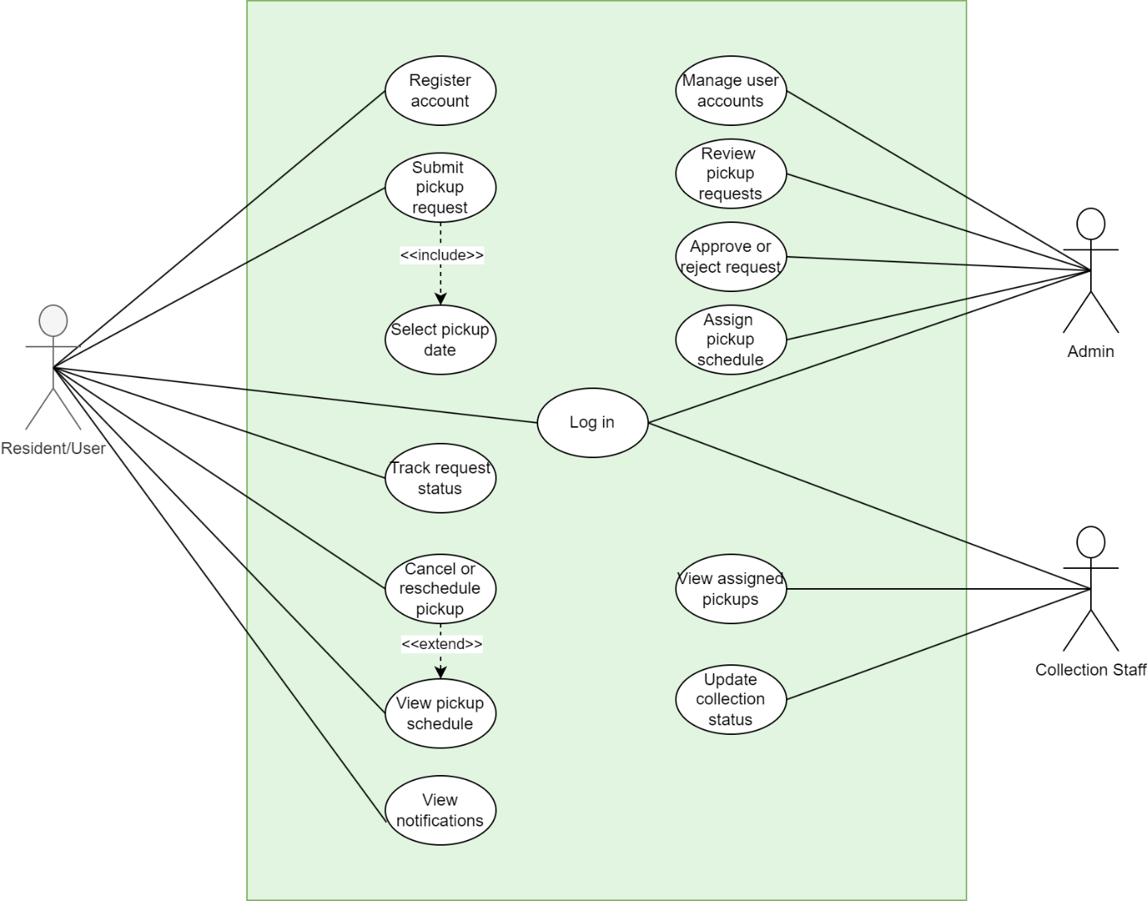
Recycling Pickup Scheduler System-Use Case Diagram

1. Introduction
This use case diagram shows how the main users interact with the Recycling Pickup Scheduler System. The system is designed to make it easier for residents to schedule recycling pickups, while admins manage the requests and collection staff handle the actual pickups.

2. Actors

Resident/User
The resident is the main user of the system. They can create an account, log in, submit a pickup request, choose a pickup date, and check their schedule. They can also track the status of their request and cancel or reschedule if needed. In addition, they receive notifications about updates.

Admin
The admin is responsible for managing the system. They review incoming pickup requests, decide whether to approve or reject them, assign pickup schedules, and manage user accounts.

Collection Staff
The collection staff carry out the pickup tasks. They can view the pickups assigned to them and update the status once the job is completed.

3. Main Use Cases
The system includes the following key functions:
- Register and log in to the system
- Submit a pickup request and select a date
- View pickup schedule and track request status
- Cancel or reschedule a pickup
- Receive notifications
- Admin reviews and processes requests
- Staff view assigned pickups and update status

4. Relationships
- The “Submit pickup request” use case includes “Select pickup date” because selecting a date is required when making a request.
- The “Cancel or reschedule pickup” use case extends “View pickup schedule” since users usually check their schedule before making any changes.

5. Conclusion
Overall, the diagram gives a clear overview of how the system works and how each user interacts with it. It shows the main features in a simple way and helps explain the system design.

